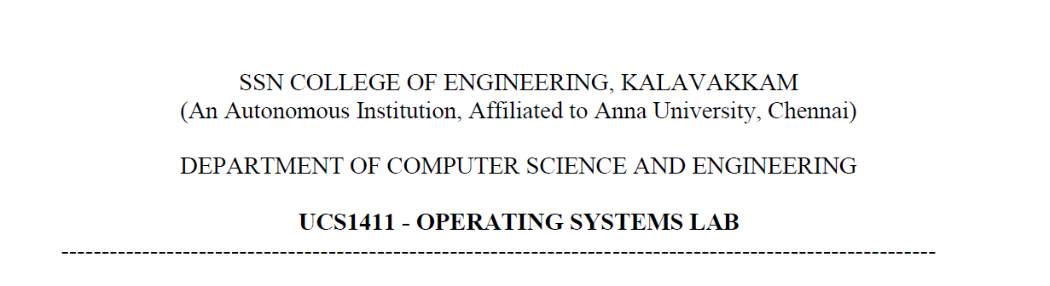

**LAB EXERCISE 7**

Name: Jayannthan P T

Dept: CSE ‘A’

Roll No.: 205001049



1. Compute ab mod N
   1. **Code:**

#include <stdlib.h>

#include <iostream>

using **namespace** std;

**long** **long** binpow(**long** **long** a, **long** **long** b, **long** **long** m)

{

    a %= m;

**long** **long** rem = 1;

    while (b > 0)

    {

        if (b & 1)

        {

            rem = rem * a % m;

        }

        a = a * a % m;

        b = b / 2;

    }

    return rem;

}

**int** main(**int** argc, **char** **const** **\***argv[])

{

**long** **long** a, b, m;

    cout << "Enter a:";

    cin >> a;

    cout << "Enter b:";

    cin >> b;

    cout << "Enter m:";

    cin >> m;

    cout << a << "^" << b << " mod " << m << " = " << binpow(a, b, m);

    return 0;

}

* 1. **Output:**

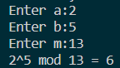



1. To Implement Sieve of Eratosthenes Algorithm
   1. **Code:**

#include <stdlib.h>

#include <vector>

#include <cstring>

#include <iostream>

using **namespace** std;

**int** main(**int** argc, **char** **const** **\***argv[])

{

    int n;

    cout << "Enter n:";

    cin >> n;

    bool is_prime[n + 1];

    memset(is_prime, true, sizeof(is_prime));

    is_prime[0] = false;

    is_prime[1] = false;

    for (**int** i = 2; i <= n; i++)

    {

        if (is_prime[i] && i * i <= n)

        {

            for (**int** j = i * i; j <= n; j += i)

            {

                is_prime[j] = false;

            }

        }

    }

    cout << "\n Prime numbers less than or equal to " << n << endl;

    for (**int** i = 2; i <= n; i++)

    {

        if (is_prime[i])

        {

            cout << i << " ";

        }

    }

    return 0;

}

* 1. **Output:**
  2. 